REPORT ON THE AIDS AWARENESS DAY

On 21 March 2012 the Bethel SDA church held an AIDS & TB Awareness day. The theme of the day was “Access To HIV Treatment is a Human Right”. The event was held at the Bethel Church, and attended by 118 adults and young people (name list attached) and over a hundred and fifty children. Attendees were people from phase 6. Some of them parents of the children at our Day Care some were regulars at our Meals on Wheels project.
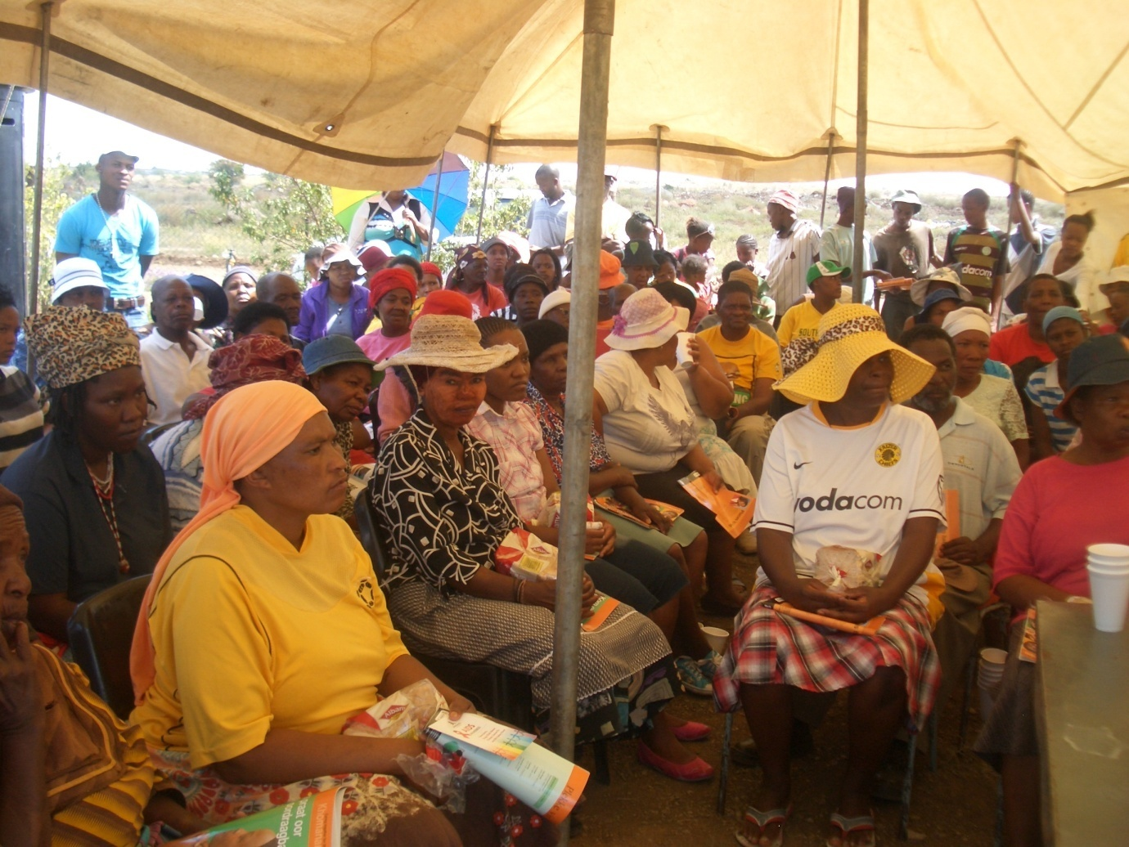
Speakers
A representative from Chris De Wet Clinic AIDS Unit Mr. Tshokolo Ramontsoe was the main speaker. An AIDS activist from Dewetsdorp Ms Riala Mkati living with AIDS was the other speaker. Mr Tshokolo spoke about the behaviour of men and how certain behaviours of men (behaviours that society does not condemn) spread the virus. He further encouraged men and women in society should take responsibility in teaching children how to behave. He commended the Bethel church for taking the initiative to inform society about the reality of HIV/AIDS and further challenged the church to take the lead in upholding morality. He emphasized the need for churches to be the moral compass for the communities. The churches need to live what they preach. “The churches must encourage people to seek medical help” he said. The traditional ceremony of lighting candles was conducted at the conclusion of everything.
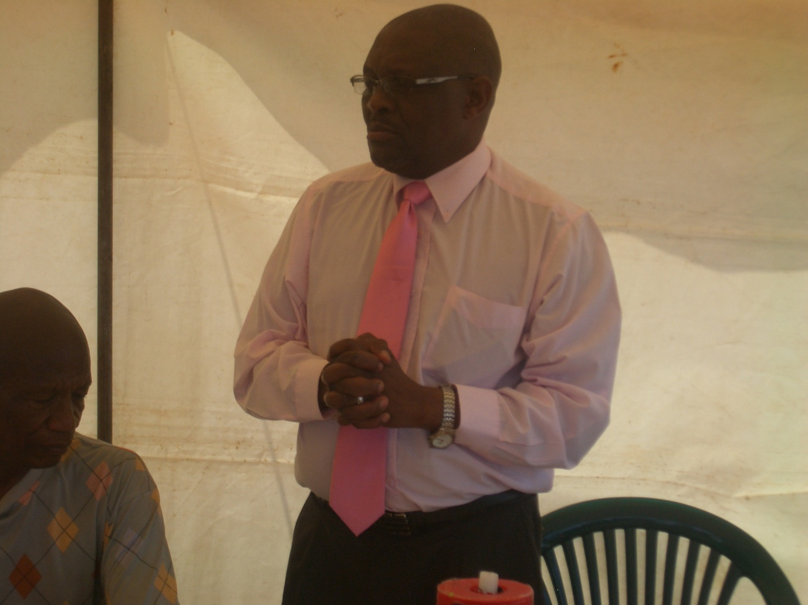
Mr Tshokolo Ramontsoe Imploring men to be responsible and stem the spread of the HI Virus
Ms Riala Mkati spoke about her near death experience until she started on the ARV Treatment. She spoke passionately about how young people live their lives without regard of God, how young people do not respect their parents. She implored young people to always be good to their parents as those parents will never desert them when the whole world turn against them. She praised the bravery and patience of her own mother who stood by her when everybody had given up on her. She spoke of how she struggled to come to terms with her status, and how angry and miserable she was. The sister revealed intimate details of her pain and suffering and how much she is healing every time she shares with other. She encouraged other never to suffer in silence. She challenged young people to seek God while they still have the strength and youth on their side. She put herself at the disposal of young people. She said that the youth cannot afford to make the same mistakes she made. She already made those mistakes on their behalf. She now spends her time addressing the youth and giving testimony. After she gave her speech, there were some who came to her for guidance and counselling. It showed that she really made an impact on the audience

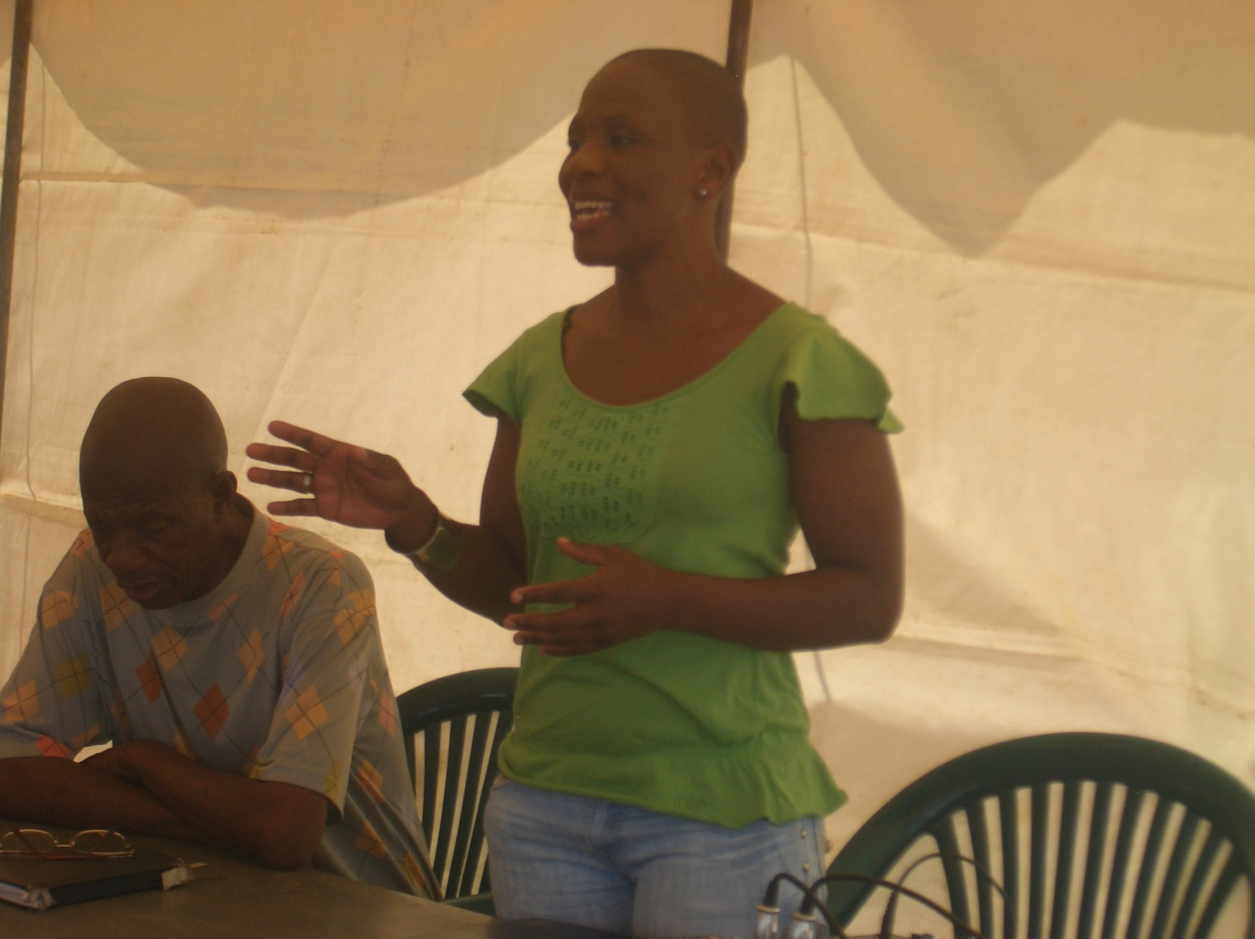
Ms Riala Showing young people the way to behave

The attendees expressed gratitude for the church to organize such good speakers who really spoke from the heart. An opportunity was given to them to speak in response. They all expressed a wish that the church continue to bring such programmes to them.

Acknowledgements

The church would not have done this without a generous sponsorship from MOWCS SA. That enabled us to prepare food for the masses, hire the tent and the sound system that went about the streets wailing and calling people to the gathering.

Shoprite, for the mobile soup kitchen. That helped to feed the children who came in big numbers. Thank you for the donation of bread that was left for Bethel Day Care.

SASKO Bloemfontein, for the generous donation of bread.

The members of the Seventh Day Adventist churches in Bloemfontein who attended. A special thank you to members of the Bethel church, who worked tirelessly to ensure that the program succeeds. Bro Molokoane and his team.

Photo gallery

